**dgSCOM Dongle Assembly**

The dgSCOM dongle has 3 pieces. The I2C interface board (PCB), the USB 2.0 to Serial FIFO Bridge Interface Board (UM232H), and a two-pin jumper.

Assemble the dongle by first plugging UM232H on to the U1 sockets (see left picture), then plugging in the two-pin jumper on J1. When the dongle is assembled correctly and D2XX driver is installed on a PC, the LED1 PWR should light up when plugging into a PC via mini-USB.

D2XX driver: <https://ftdichip.com/drivers/d2xx-drivers/>

**I2C Interface Module and the dgSCOM software/GUI Guide**

I2C Interface Module

Install dgSCOM software/GUI with **dgSCOM Setup.exe**.

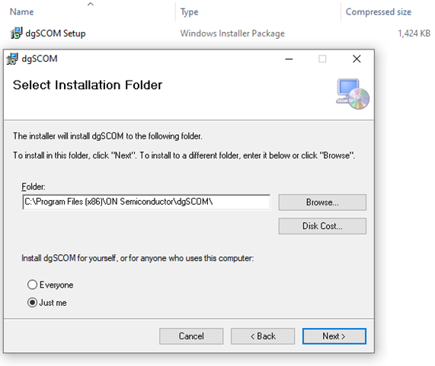

After installing dgSCOM successfully, dgSCOM.exe ICON will appear on the desktop. Click on **dgSCOM.exe** to lunch the GUI.

**Using dgSCOM software/GUI**

dgSCOM should recognize the I2C Interface Module as UM232H. Click the **Connect** button to establish connection between the GUI and the I2C Interface Module. **FT_OK** shown after connecting the GUI to the I2C Interface Module properly.

